Logging in to the WPA State Site FTP File Manager Program
Follow the steps here to login to the WPA State site for chapter page updates using the secure File Manager access. It is highly recommended that you use this method rather than using a standard FTP software program to prevent unwanted access by hackers.
NOTE: The User Name and Password provided to you will give you access to the full WPA State website files. Please use these steps to locate your chapter’s folder and ONLY modify those files!
Step | Description
1 | Access File Manager at https://015ed2b.netsolhost.com/fileman/fileman.cgi
2 | At the login window, enter the provided User Name and Password.  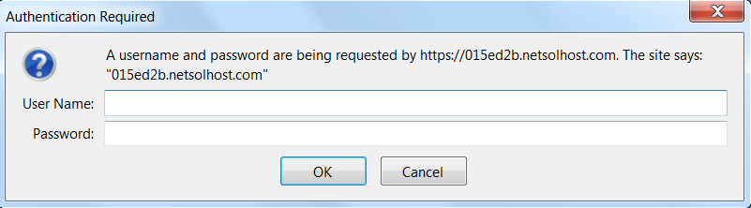
3 | On the main File Manager page, click on the “www” folder.  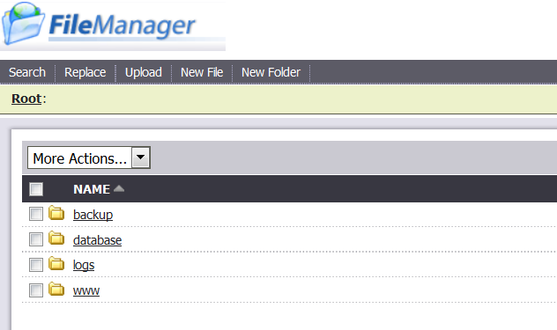
4 | Click on the “Chapters” folder.  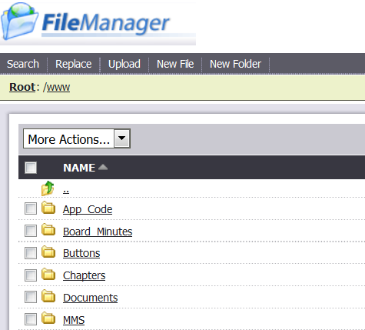
5 | Click on your chapter’s folder.  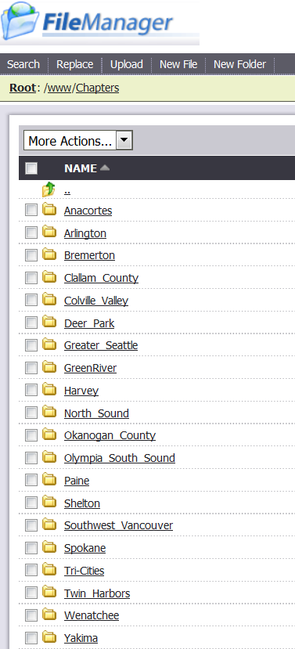
6 | Select “Upload” from the menu bar, then browse for the files on your local drive and select the “Upload” button next to the File line.  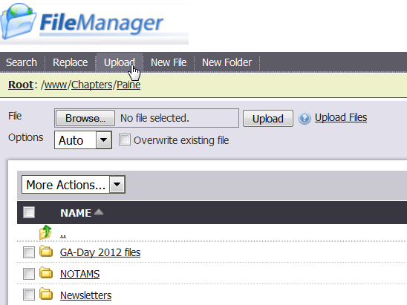
7 | After completing upload, select the “Logout” link at the upper right of the page.

